VISVESVARAYA TECHNOLOGICAL UNIVERSITY,
BELGAUM, KARNATAKA

MAJOR-PROJECT-I
REPORT ON
“Design and Development of AI Agents for Academic Project Planning and Management”
Submitted in partial fulfilment of the requirement for the award of the degree of
BACHELOR OF ENGINEERING
IN
COMPUTER SCIENCE AND ENGINEERING
Submitted by
Sl. No | USN | NAME
1. | 2SD22CS130 | POOJA S DODDAGOUDAR
2. | 2SD23CS400 | AMBIKA T CHAVAN
3. | 2SD23CS407 | PUNARVASU SHETAKE
4. | 2SD23CS409 | SMITAL S KAGINKAR

Under the Guidance of

Prof. Radhika Amashi
Dept. of CSE, SDMCET, Dharwad

DEPARTMENT OF COMPUTER SCIENCE AND ENGINEERING
S.D.M. COLLEGE OF ENGINEERING & TECHNOLOGY,
DHARWAD-580002
2025-26
S.D.M COLLEGE OF ENGINEERING & TECHNOLOGY,
DHARWAD –580002
DEPARTMENT OF COMPUTER SCIENCE AND ENGINEERING
CERTIFICATE
Certified that the project work and presentation entitled “Design and Development of AI Agents for Academic Project Planning and Management” is a bonafide work carried out by POOJA S DODDAGOUDAR(2SD22CS130),
AMBIKA CHAVAN (2SD23CS400), PUNARVASU SHETAKE (2SD23CS407), and SMITAL KAGINKAR (2SD23CS409), students of S. D. M. College of Engineering & Technology, Dharwad, in partial fulfillment for the award of Bachelor of Engineering in Computer Science and Engineering of Visvesvaraya Technological University, Belgaum, during the year 2025-2026. It is certified that all corrections/suggestions indicated for internal assessment have been incorporated in the report deposited in the department library. The Project has been approved, as it satisfies the academic requirements in respect of project report prescribed for the said degree.

----------------------- ------------------------
Prof. Radhika Amashi Dr. U P Kulkarni
Project Guide HoD-CSE
External Viva
Name of Examiners Signature with date
1. ______________________
2. ___________________
ABSTRACT
Academic projects constitute a vital component of engineering and higher education curricula, as they enable students to apply theoretical knowledge to practical and real-world problems while developing essential skills such as technical proficiency, research aptitude, teamwork, and critical thinking. Despite their importance, students frequently encounter significant challenges in managing academic projects effectively. These challenges include inadequate project planning, improper task allocation, limited progress monitoring, inefficient collaboration, and insufficient research guidance. Conventional academic project management practices rely largely on manual coordination, fragmented tools, and static documentation, which often result in uneven workload distribution, reduced mentor visibility, missed deadlines, and compromised project outcomes.
To overcome these limitations, this project focuses on the design and development of AI agents for academic project planning and management. The proposed system leverages Artificial Intelligence (AI) techniques through Large Language Models (LLMs) implemented using Ollama, ensuring local inference, data privacy, and offline usability. The system integrates MongoDB for structured data storage and Streamlit for developing an interactive and user-friendly interface. Intelligent AI agents assist students and mentors in various academic activities, including automated literature review collection and summarization, objective generation and refinement, methodology recommendation, agile Scrum-based task planning, structured timeline creation, real-time progress tracking, and automated generation of IEEE-compliant academic reports.
By providing a centralized and intelligent platform for collaboration, monitoring, and documentation, the proposed system significantly reduces project management overhead and enhances transparency, accountability, and coordination among project stakeholders. The integration of AI-driven automation enables students to focus more on innovation, implementation, and learning rather than administrative tasks. Overall, the system aims to improve productivity, academic quality, and learning outcomes while bridging the gap between academic project requirements and professional project management practices.

TABLE OF CONTENTS

Chapters |  | Page No
 | Introduction | 1
 | Sustainable Development Goals (SDG) | 2
 | Objectives | 3
 | Literature Review | 4
 | Detailed Design | 5
 | Project Specific Requirements | 14
 | Implementation | 19
 | Results | 21
 | Conclusion | 30
References |  | 31

LIST OF FIGURES

FIGURE NO. | FIGURE DESCRIPTION | PAGE NUMBER
Fig-1 | System Architecture | 5
Fig-2 | Entity – Relationship Diagram | 7
Fig-3 | Flow Diagram | 8
Fig-4 | Use Case Diagram | 9
Fig-5 | User Registration & Role Assignment | 10
Fig-6 | Domain & Project Selection | 10
Fig-7 | Task Breakdown & Allocation | 10
Fig-8 | Research Summarization | 11
Fig-9 | Progress Tracking | 11
Fig-10 | Collaboration & Communication | 11
Fig-11 | Documentation & Reporting | 12
Fig-12 | Evaluation & Feedback | 12
Fig-13 | Activity Diagram | 13
Fig-14 | Registration Page | 21
Fig-15 | Login Page | 21
Fig-16 | Lead Credentials Page | 22
Fig-17 | Lead Dashboard Page | 22
Fig-18 | Mentor credentials Page | 23
Fig-19 | Mentor Dashboard Page | 23
Fig-20 | Member Credentials Page | 24
Fig-21 | Member Dashboard Page | 24
Fig-22 | Literate Review Agent Page | 25
Fig-23 | Objectives Generator Page | 25
Fig-24 | Agile Scrum Planner Page | 26
Fig-25 | Project Timelines Page | 26
Fig-26 | IEEE Report Generator Page | 27
Fig-27 | Report Editor Page | 27
Fig-28 | Mentor Feedback Page | 28
Fig-29 | AI Evaluation and Feedback Page | 28
Fig-30 | MongoDB Collections | 29

PROBLEM STATEMENT

Academic project management often suffers from poor planning, ineffective task allocation, limited progress monitoring, and lack of structured research guidance. Students rely on manual coordination and fragmented tools, leading to inefficiencies, missed deadlines, and reduced project quality. There is a need for an intelligent, centralized system that supports structured planning, collaboration, monitoring, and documentation. This project aims to design and develop AI agents to address these challenges and enhance academic project execution.

CHAPTER 1
INTRODUCTION
Academic projects are a fundamental component of higher education, enabling students to apply theoretical knowledge to practical problems while developing essential skills such as problem-solving, teamwork, innovation, and decision-making. However, many students face difficulties in managing academic projects due to challenges in research collection, project planning, task allocation, progress monitoring, and resource management. The reliance on fragmented tools such as spreadsheets, messaging applications, or manual coordination often leads to inefficiencies, communication gaps, uneven workload distribution, and missed deadlines. With the increasing complexity of engineering projects and the growing emphasis on research-oriented learning, there is a clear need for structured and intelligent solutions to support effective academic project management.
To address these challenges, this project proposes TeamCollab, an AI-assisted academic project planning and management platform designed to support students throughout the project lifecycle. The system is implemented as a role-based platform for Project Leads, Mentors, and Members, offering customized dashboards for each role. TeamCollab integrates intelligent AI agents to assist in literature analysis, objective formulation, methodology recommendation, Scrum-based task planning, timeline creation, progress tracking, and performance evaluation. By automating repetitive academic tasks and providing a centralized platform for collaboration, monitoring, and structured reporting, the system reduces management overhead, enhances productivity, and bridges the gap between academic project requirements and professional project management practices.

CHAPTER 2
SUSTAINABLE DEVELOPMENT GOALS (SDG)
The United Nations' 17 Sustainable Development Goals (SDGs) provide a comprehensive framework that increasingly shapes how engineering projects are conceived, designed, and executed worldwide. Engineers play a pivotal role in achieving these goals, as infrastructure, technology, and innovation are fundamental enablers of sustainable development. From SDG 6 (Clean Water and Sanitation) driving water treatment facility designs to SDG 7 (Affordable and Clean Energy) influencing renewable energy projects, these goals are no longer peripheral considerations but central to project planning and evaluation. Modern engineering projects are expected to demonstrate clear alignment with relevant SDGs, often requiring environmental impact assessments, social benefit analyses, and long-term sustainability metrics that extend beyond traditional cost-benefit calculations.
Engineering projects now commonly integrate multiple SDGs simultaneously, recognizing the interconnected nature of sustainable development. For instance, a transportation infrastructure project might address SDG 9 (Industry, Innovation and Infrastructure) while also contributing to SDG 11 (Sustainable Cities and Communities) through reduced emissions and improved urban mobility, and SDG 13 (Climate Action) through low-carbon construction methods. This multi-dimensional approach requires engineers to adopt systems thinking, considering not just technical performance but also social equity, environmental protection, and economic viability throughout a project's lifecycle.
The SDG framework has transformed engineering practice by establishing measurable targets and indicators that help quantify project impacts beyond traditional engineering metrics. Projects are increasingly evaluated on their contribution to goals like SDG 3 (Good Health and Well-being), SDG 12 (Responsible Consumption and Production), and SDG 15 (Life on Land), requiring engineers to collaborate with diverse stakeholders including environmental scientists, social planners, and community representatives. This paradigm shift has elevated the profession's responsibility, positioning engineers as key agents of sustainable development who must balance technical excellence with ethical considerations, resource efficiency, and long-term societal benefit in every project they undertake.
In alignment with the United Nations Sustainable Development Goals (SDGs), the proposed project “Design and Development of AI Agents for Academic Project Planning and Management” primarily maps to SDG 4: Quality Education by enhancing project-based learning through intelligent planning, research support, collaboration, and performance evaluation in higher education. The project also contributes to SDG 9: Industry, Innovation and Infrastructure by developing an innovative AI-driven digital platform that integrates modern technologies such as Large Language Models and agile methodologies. Additionally, it supports SDG 8: Decent Work and Economic Growth by equipping students with industry-relevant project management skills, collaborative practices, and AI exposure, thereby improving their employability and preparedness for professional environments.

CHAPTER 3
OBJECTIVES
- To collect and summarize relevant academic research information.
- To plan projects with structured timelines, milestones, and suitable methodologies.
- To break down goals into tasks, allocate them to team members, and track progress with alerts.
- To facilitate collaboration and manage resources through communication hubs and repositories.
- To generate structured documentation and provide AI-driven evaluation and feedback.

CHAPTER 4
Author / Year | Key Findings | Limitations | Relevance to Our Project
Wrike (2025) [1] | Provides AI-powered drafting, summarization, and workflow automation tools for project management. | Designed mainly for enterprise use; requires customization for academic environments. | Demonstrates how AI can automate project management tasks, motivating AI adoption in academic projects.
SciSummary (2023) [2] | Uses AI to automatically summarize scientific articles, reducing manual literature review effort. | Summaries may miss contextual nuances and depend on input quality. | Supports the use of AI-based literature review and summarization agents in the proposed system.
Smith et al. (2025) [3] | Proposes AI-based task modeling using large multimodal models and digital twins for automated task planning. | Complex implementation and high computational requirements. | Provides a foundation for AI-driven task breakdown and allocation in Scrum-based academic projects.
Iris.ai (2025) [4] | Enables AI-powered research discovery and literature navigation across multiple academic databases. | Integration with diverse databases can be challenging. | Enhances efficiency of literature analysis and research exploration for academic projects.
Zhang et al. (2024) [5] | Introduces AI-optimized task allocation techniques focused on resource and skill optimization in projects. | Mainly applicable to software industry projects; requires adaptation for academics. | Guides AI-based task allocation and skill matching for student project teams.
LITERATURE SURVEY

CHAPTER 5
DETAILED DESIGN

System Architecture
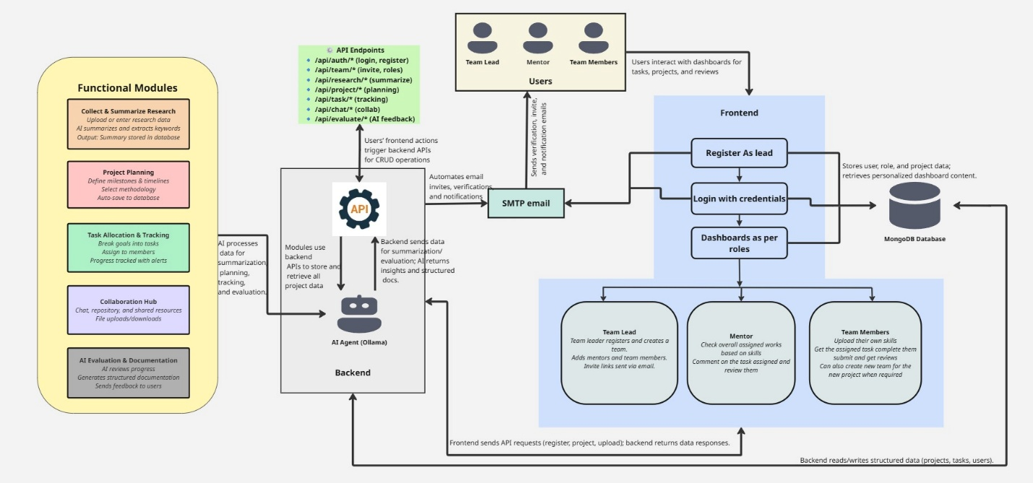

Fig 1: System architecture

1. Overview of the Architecture
- The system architecture represents an AI-assisted academic project planning and management platform (TeamCollab).
- It follows a modular and layered design to ensure scalability, security, and maintainability.
- The architecture integrates frontend interfaces, backend services, AI agents, and database components.

2. Users and Frontend Layer
- The system supports three primary user roles:
  - Project Lead
  - Mentor
  - Team Member
- Users interact with the system through a web-based frontend interface.
- Key frontend functionalities include:
  - User registration and authentication
  - Role-based dashboard access
  - Project creation, task updates, and resource uploads
- Dashboards are dynamically displayed based on the user’s role

3. Backend and API Layer
- The backend acts as the central control unit of the system.
- It exposes multiple API endpoints to handle:
  - User authentication and authorization
  - Project planning and task allocation

  - Research upload and summarization
  - Collaboration and evaluation
- The backend validates user requests and routes them to the appropriate modules.

4. AI Agent Layer (Ollama Integration)
- The system integrates AI agents powered by Large Language Models (LLMs)
using Ollama.
- AI agents perform intelligent tasks such as:
  - Literature review summarization
  - Objective formulation
  - Scrum-based task planning
  - Progress evaluation and feedback generation
  - Automated IEEE-style report creation
- Local LLM inference ensures data privacy, offline capability, and reduced latency.

5. Functional Modules
- The system consists of several functional modules:
    - Research Summarization Module: Collects and summarizes academic papers.
    - Project Planning Module: Defines objectives, milestones, and timelines.
    - Task Allocation Module: Breaks objectives into tasks and assigns them to members.
    - Collaboration Module: Supports communication and shared resources.
    - Evaluation and Documentation Module: Generates AI-assisted feedback and reports.
- Each module interacts with the backend and AI agents for processing.

6. Database Layer (MongoDB)
- MongoDB is used as the primary data storage system.
- It stores structured project-related data including:
  - User profiles and roles
  - Project details and objectives
  - Task assignments and progress updates
  - Research summaries and reports
- The database supports fast read and write operations.

7. Notification and Email Services
- The system integrates an SMTP-based email service.
- Automated emails are sent for:
  - User registration confirmation
  - Task assignment notifications
  - Deadline reminders
  - Evaluation and feedback alerts
- This enhances communication and user engagement.

8. Data Flow in the System
- Users perform actions through the frontend dashboards.
- Requests are sent to backend APIs.
- Backend processes requests and invokes AI agents when required.
- AI-generated outputs are stored in the database.
- Processed information is displayed back to users.
- Notifications are sent through the email service.
Entity-Relationship Diagram
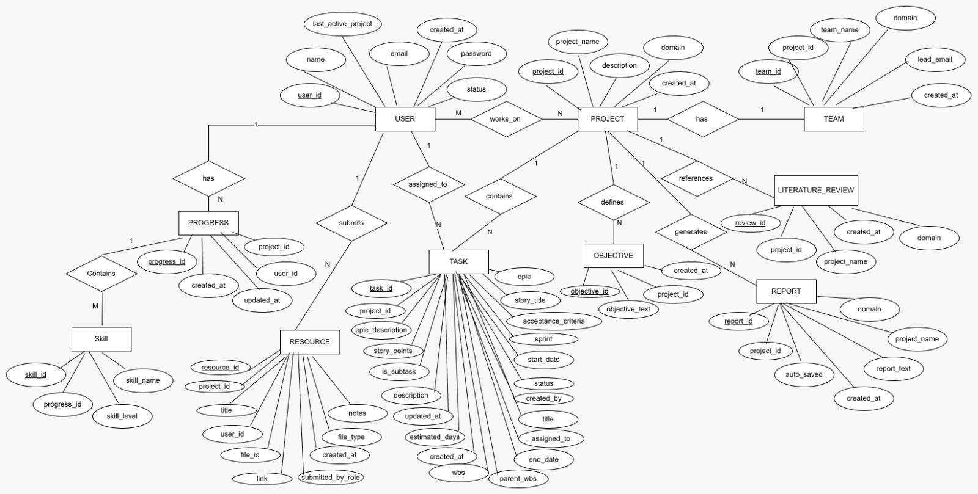
Fig 2: Entity – Relationship Diagram

Flow Diagram
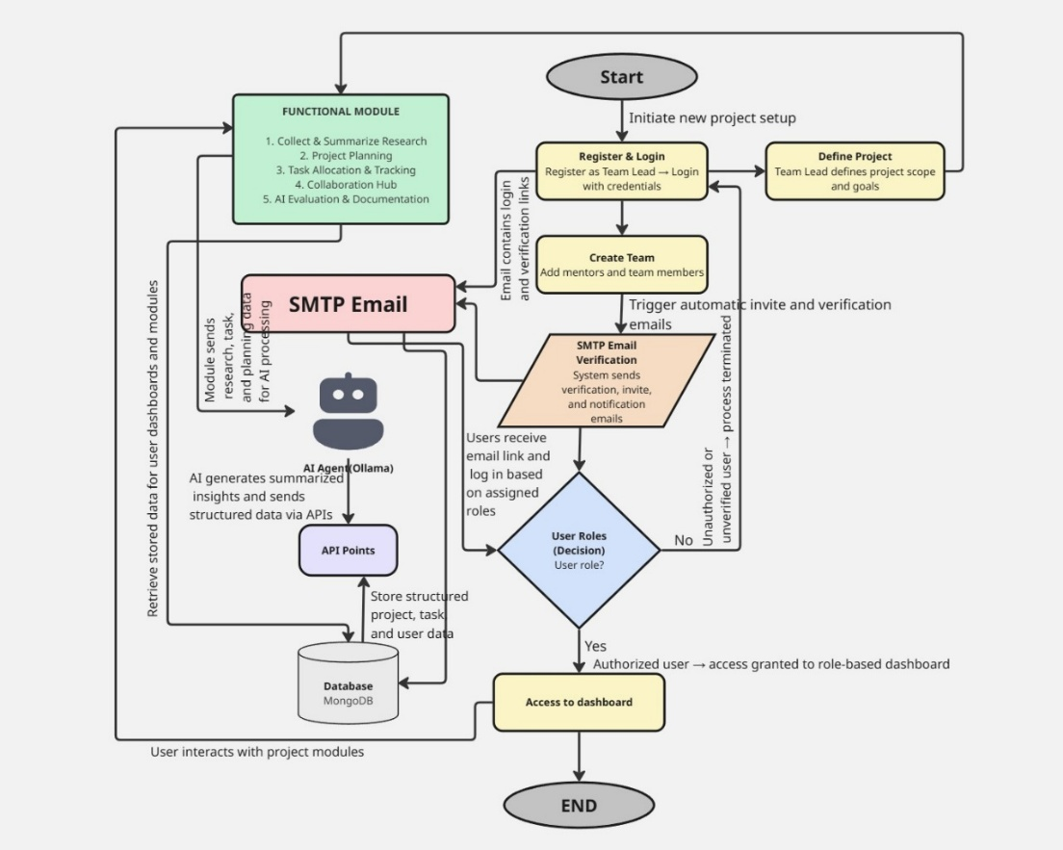
Fig 3: Flow Diagram
- The process begins with the Project Lead registering and logging in to the system using valid credentials.
- After successful login, the Project Lead defines the project scope, objectives, and goals.
- The Project Lead then creates a team by adding mentors and team members.
- The system automatically triggers SMTP email notifications for user verification, invitations, and alerts.
- Invited users receive verification links and log in based on their assigned roles.
- The system performs role verification to determine authorized access.
- Authorized users are granted access to role-based dashboards, while unauthorized users are denied access.
- Users interact with various functional modules, including:
- Research collection and summarization
- Project planning
- Task allocation and tracking
- Collaboration and communication
- Evaluation and documentation
- The backend invokes AI agents (Ollama) to generate summaries, insights, and structured data.
- All user, project, and task data are stored and retrieved from the MongoDB database through APIs.
- The workflow ends with users continuously interacting with dashboards for effective project execution.

Use Case Diagram
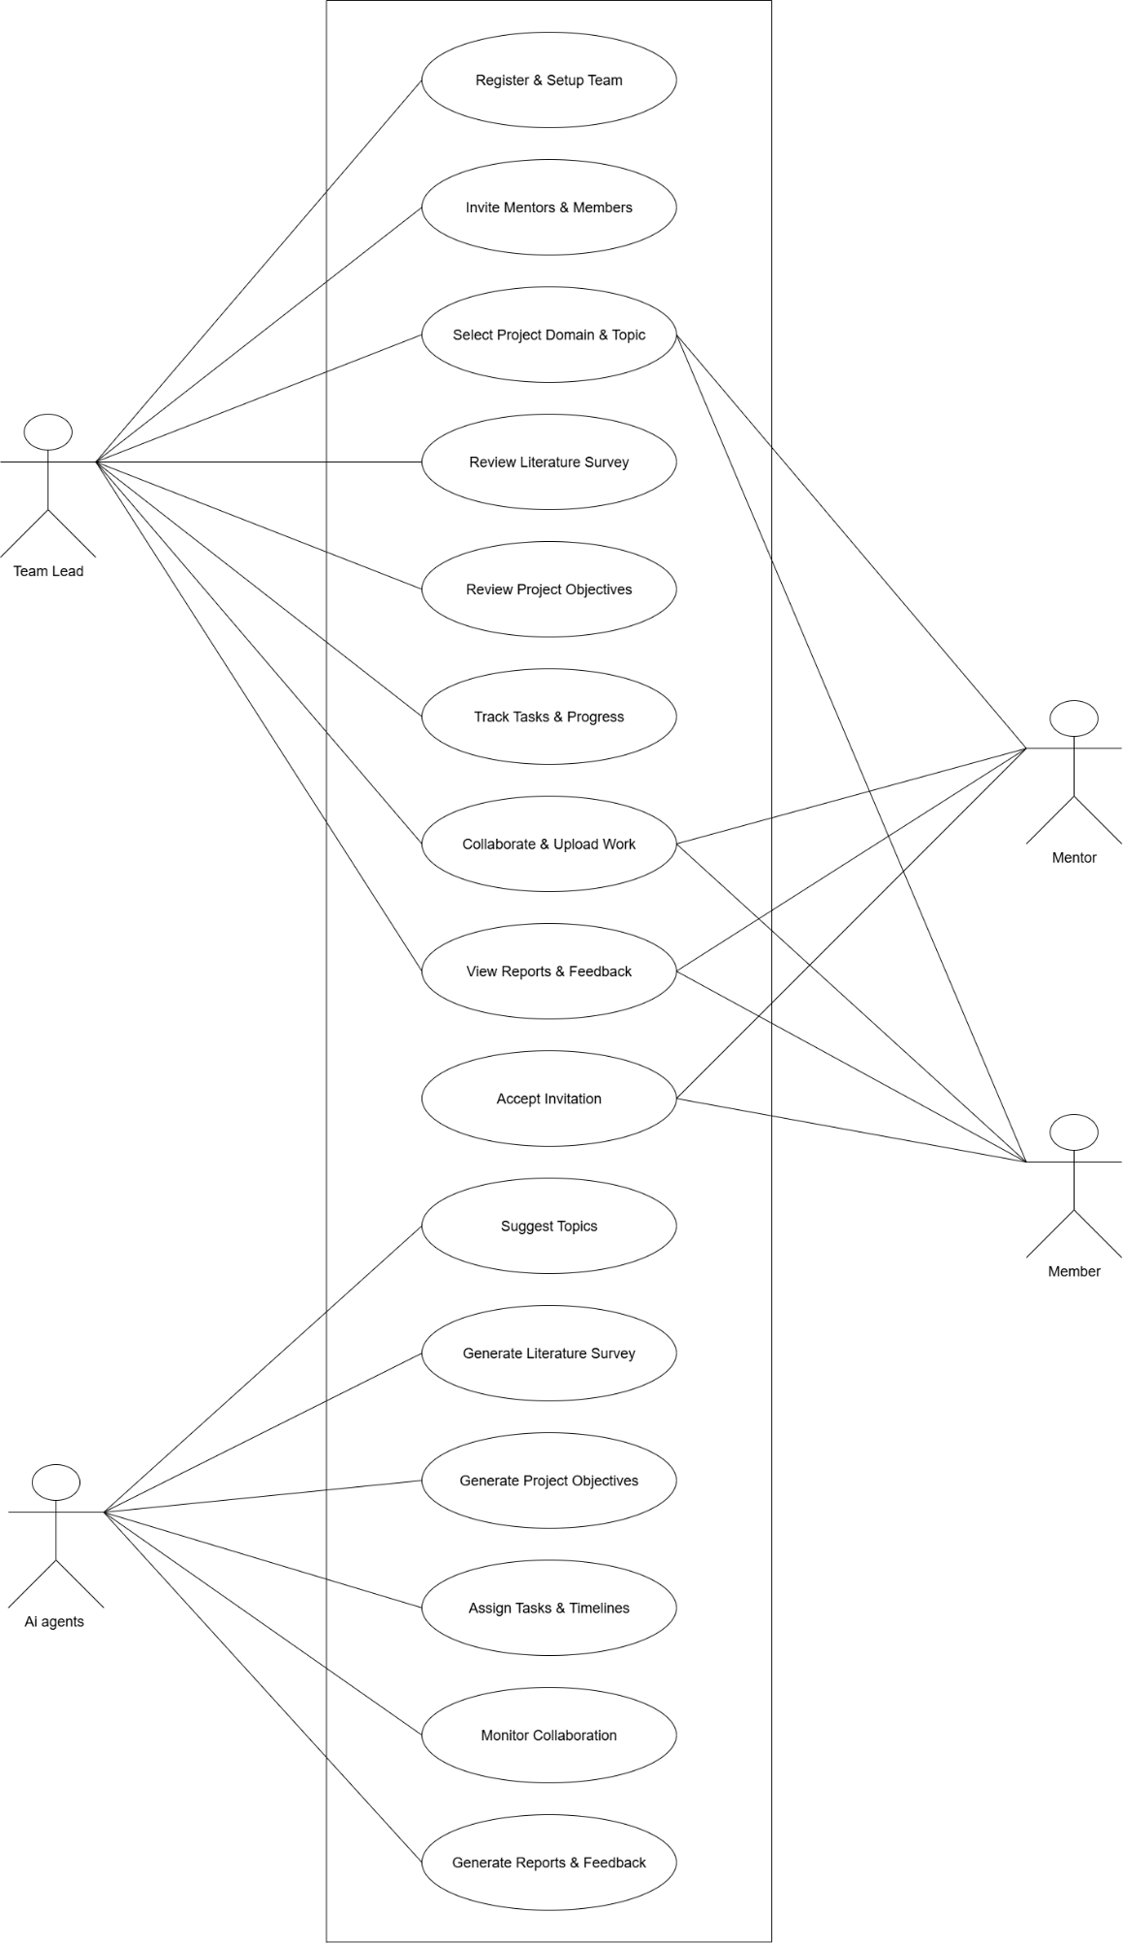
Fig 4: Use Case Diagram

Sequence Diagrams

User Registration & Role Assignment
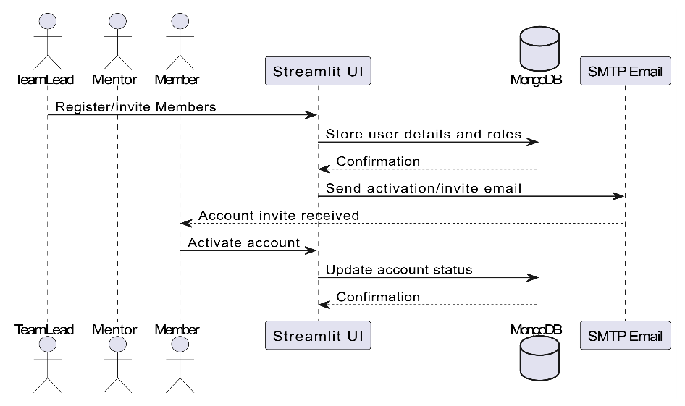

Fig 5: User Registration & Role Assignment
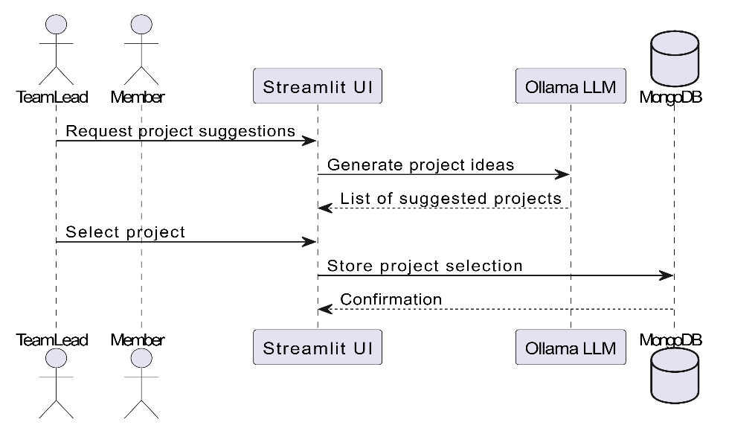
Domain & Project Selection

Fig 6: Domain & Project Selection
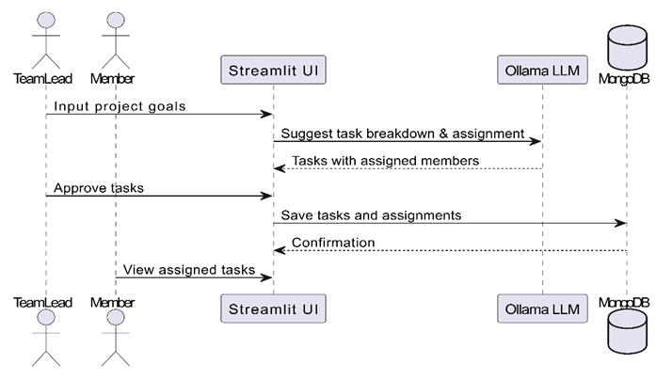
Task Breakdown & Allocation

Fig 7: Task Breakdown & Allocation

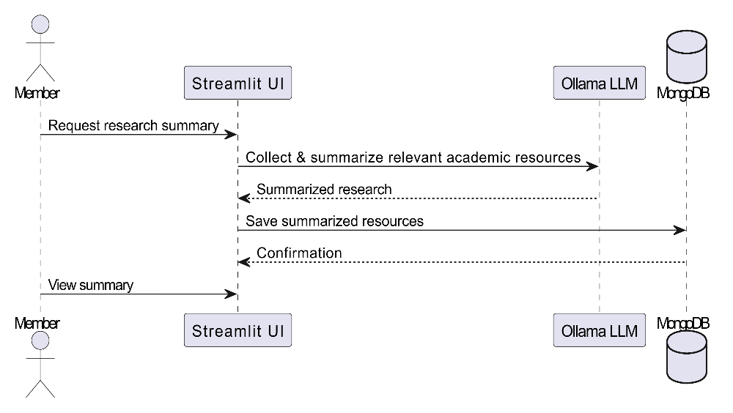
Research Summarization

Fig 8: Research Summarization

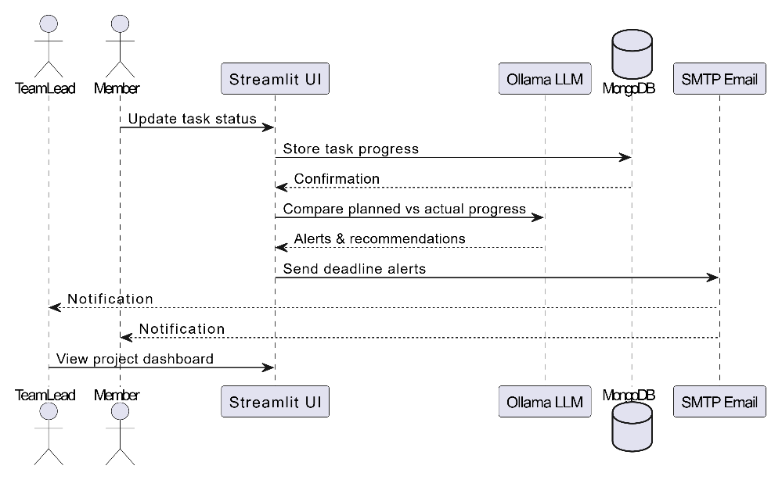
Progress Tracking

Fig 9: Progress Tracking

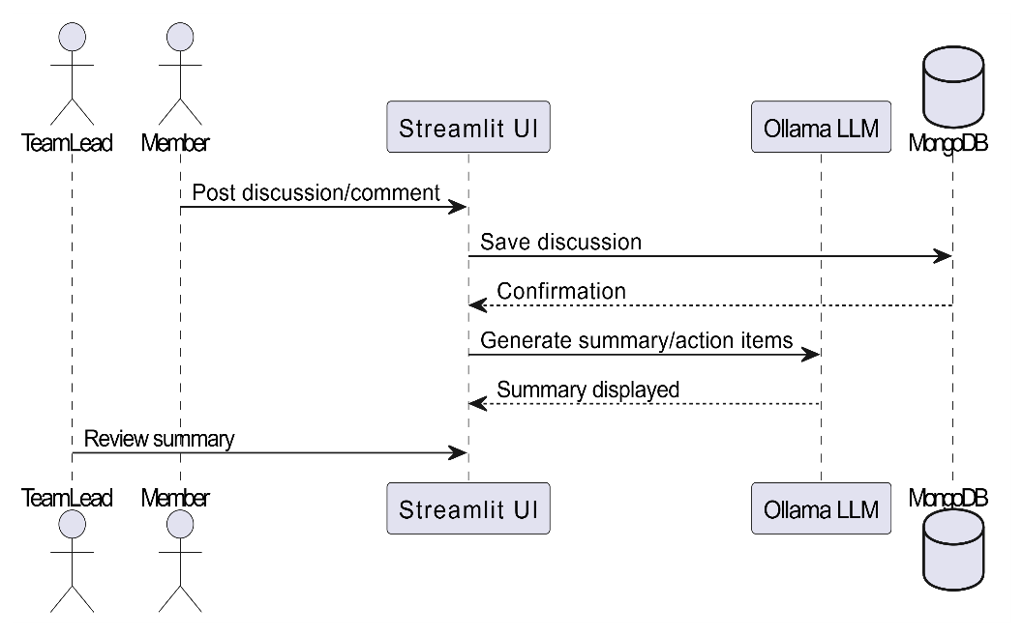
Collaboration & Communication

Fig 10: Collaboration & Communication

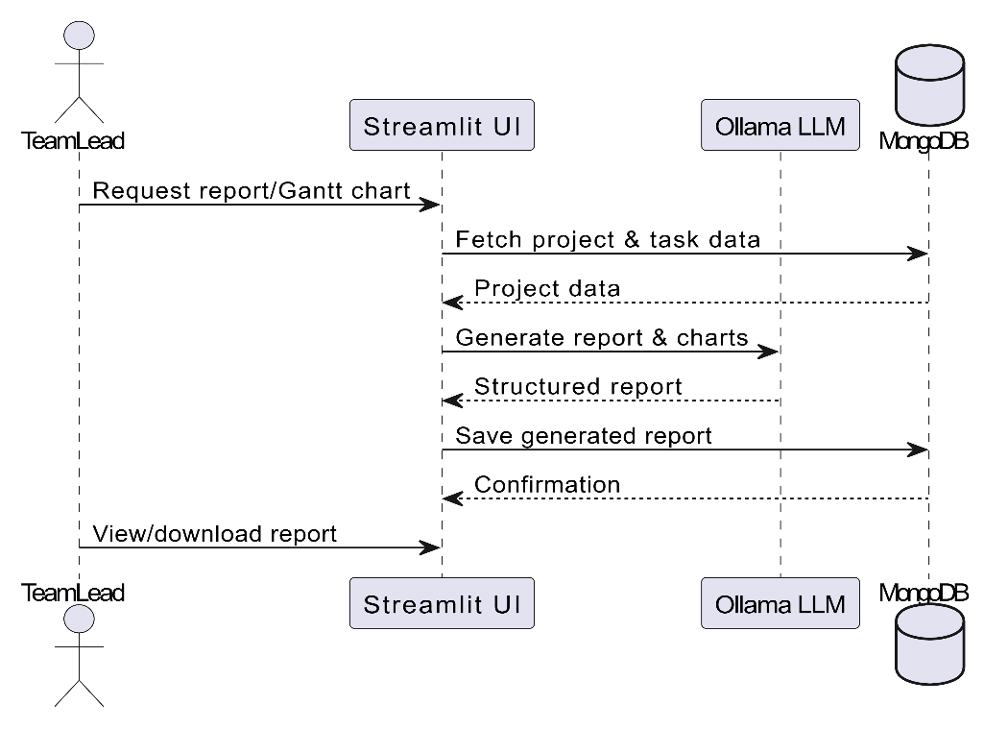
Documentation & Reporting

Fig 11: Documentation & Reporting

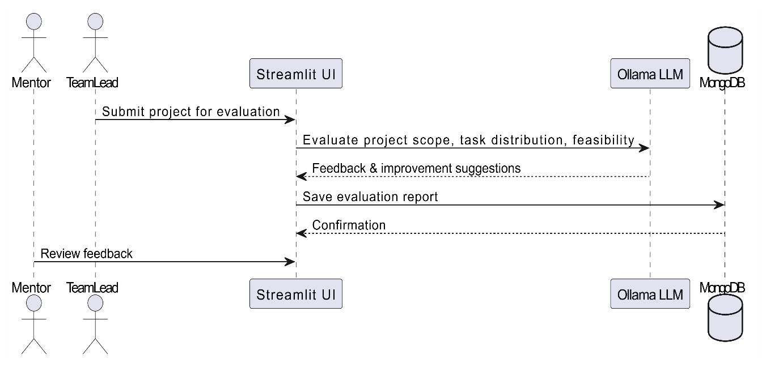
Evaluation & Feedback
Fig 12: Evaluation & Feedback

Activity diagram
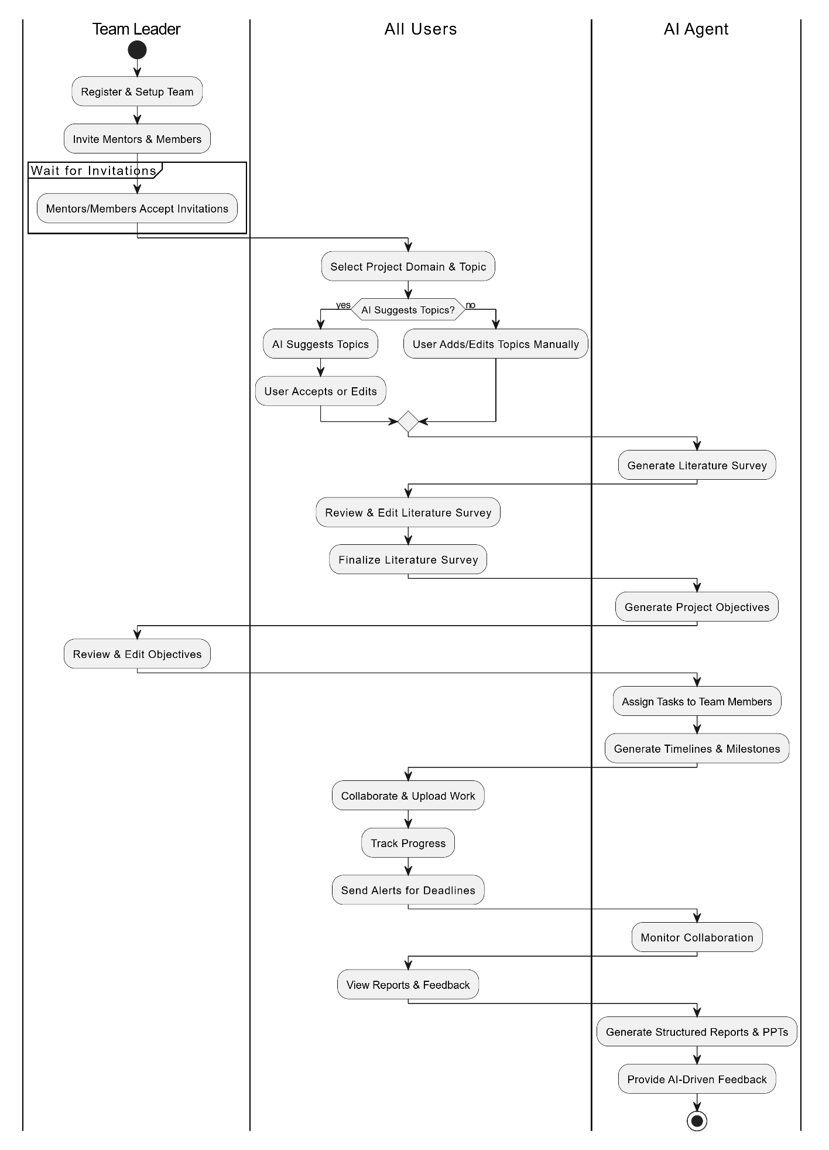
Fig 13: Activity Diagram

CHAPTER 6
PROJECT SPECIFIC REQUIREMENTS
The requirements define the expected functionality, performance characteristics, security constraints, and quality attributes necessary for the successful implementation and operation of the system. These requirements ensure that the system meets academic project management needs while maintaining scalability, reliability, and usability.

Functional Requirements
Functional requirements specify the core features and services that the system must provide to users. These requirements define how the system behaves, how users interact with it, and how different components work together to support academic project planning and management.
- Role-Based Access Control
The system shall support role-based access to ensure structured responsibilities and controlled access to features. Three primary user roles are defined:
- Project Lead: Responsible for creating projects, defining objectives, managing team members, assigning tasks, and monitoring overall project progress.
- Mentor: Oversees project quality, reviews progress, evaluates submissions, provides feedback, and ensures academic standards are met.
- Team Member: Executes assigned tasks, updates progress, uploads deliverables, and collaborates with other members.
Each role is provided with a dedicated dashboard displaying only the relevant features and data. This separation improves security, clarity, and usability while preventing unauthorized access to sensitive information.

- AI-Based Project Idea Generation
- The system shall provide an AI-driven project idea generation module that assists students during the initial phase of project selection.
- By analyzing user inputs such as domain of interest, academic level, and keywords, the AI agent generates relevant, innovative, and feasible project ideas.
- This feature reduces dependency on manual brainstorming and helps students identify research-worthy topics aligned with academic objectives.

- Automated Literature Review and Summarization
- To support research-oriented learning, the system shall include an automated literature review module.
- The AI agent retrieves research papers, articles, and technical resources from reliable academic sources and generates concise summaries highlighting key findings, methodologies, and research gaps.
- This feature helps students understand existing work efficiently and supports evidence-based project planning while reducing the time spent on manual literature analysis.

- Intelligent Objective Generation and Selection
- Based on the analyzed literature and project domain, the system shall generate well-defined project objectives using AI agents.

- These objectives are designed to be clear, measurable, achievable, and aligned with academic requirements.
- Users can review, modify, or select objectives that best match their project scope. This ensures that projects are goal-oriented and properly structured from the beginning.

- Scrum-Based Task Planning with Skill Matching
- The system shall support Scrum-based task planning, enabling projects to be divided into manageable tasks and milestones.
- Tasks are organized into sprints with estimated timelines and deliverables.
- The AI agent performs skill matching by analyzing team members expertise and assigning tasks accordingly.
- This promotes balanced workload distribution, improves efficiency, and ensures optimal utilization of team skills.

- Progress Tracking and Evaluation
- The system shall provide real-time progress tracking and performance evaluation features.
- Team members can update task status, while project leads and mentors can monitor progress through visual indicators such as completion percentages and timelines.
- The system generates alerts and reminders for pending tasks and deadlines, ensuring timely execution and accountability throughout the project lifecycle.

- IEEE-Style Report Generation and Export
- The system shall support automated academic report generation in IEEE format.
- Based on project data, tasks, objectives, and progress updates, the AI agent generates structured reports including abstract, introduction, methodology, results, and conclusion. Users can export reports in standard formats such as PDF or DOCX, ensuring compliance with institutional and academic guidelines.

Non-Functional Requirements
Non-functional requirements define the quality attributes and operational constraints of the system. These requirements ensure that the platform is reliable, secure, scalable, and maintainable.

- Scalability
- The system shall be scalable to support multiple projects and teams simultaneously without degradation in performance.
- The database and application architecture are designed to accommodate growing user numbers and increased data volume as academic usage expands.

- High Availability and Reliability
- The system shall ensure high availability of AI services with fallback mechanisms in case of service failure.
- If the primary AI model is unavailable, alternative models or predefined logic ensure uninterrupted system functionality.
- This enhances reliability and minimizes downtime during critical project phases.

- Security and Authentication
- The system shall implement secure authentication and authorization mechanisms to protect user data and project information.
- Role-based permissions ensure that users can access only authorized features and data. Secure login and data storage mechanisms safeguard academic content and personal information.

- Maintainability and Modularity
- The system shall be designed using a modular and maintainable architecture.
- Each component, including dashboards, AI agents, and database modules, operates independently, allowing easy updates, debugging, and future enhancements.
- Clean code practices and documentation support long-term system maintenance.

- Usability
- The system shall provide a user-friendly interface with intuitive navigation and clear workflows.
- The design focuses on simplicity to ensure that students and mentors with varying technical backgrounds can use the platform effectively with minimal training.

Comparison of TeamCollab with Jira
- Purpose and Application Domain
- Jira
- Designed primarily for industry-level software development projects.
- Focuses on issue tracking, sprint management, and product delivery.
- Optimized for commercial environments where deadlines, bug tracking, and productivity are critical.
- Supports software-centric workflows rather than academic processes.
- TeamCollab
- Specifically developed for academic project planning and management.
- Supports complete academic workflows including project proposal approval, literature review, mentor evaluation, and final report submission.
- Aligns project execution with institutional academic guidelines and assessment criteria.
- Emphasizes structured learning and research-oriented project development.

- Target Users
- Jira
- Intended for software developers, testers, project managers, and enterprise teams.
- Assumes users have prior experience with Agile methodologies and project management tools.
- Role definitions are industry-centric (developer, admin, product owner).
- TeamCollab
- Designed for students, Project Leads, and academic Mentors.
- Provides guided workflows suitable for learners and first-time project developers.
- Offers role-specific dashboards tailored to academic responsibilities.

- AI Integration and Automation
- Jira
- Provides rule-based automation limited to workflow transitions and notifications.
- Lacks built-in intelligent assistance for research or academic tasks.
- Does not support AI-driven content generation or academic guidance.
- TeamCollab
- Integrates intelligent AI agents as a core system component.
- Automates academic tasks such as topic selection, literature survey generation, and objective formulation.
- Supports AI-assisted task planning, progress evaluation, and report generation.

- Mentor Involvement and Evaluation
- Jira
- Supports managerial oversight focused on task tracking and sprint completion.
- Does not provide features for academic supervision or evaluation.
- Lacks structured feedback mechanisms aligned with academic assessment.
- TeamCollab
- Provides dedicated mentor dashboards for continuous academic monitoring.
- Enables AI-assisted evaluation, feedback generation, and progress review.
- Supports mentor-guided learning and academic quality assurance.

- Task Planning and Workflow Management
- Jira
- Uses Scrum and Kanban boards focused on sprint execution and delivery efficiency.
- Task planning is oriented toward product features and bug resolution.
- Emphasizes speed and productivity over learning outcomes.
- TeamCollab
- Uses Scrum-based planning adapted for academic milestones and timelines.
- Aligns tasks with learning objectives, research goals, and submission deadlines.
- Ensures balanced workload distribution to promote collaboration and learning.

- Documentation and Reporting
- Jira
- Does not provide native support for academic documentation formats.
- Report preparation is manual and external to the system.
- Lacks automated documentation assistance.
- TeamCollab
- Automatically generates structured academic documents.
- Supports IEEE-style report generation aligned with institutional standards.
- Reduces manual documentation effort through AI-assisted content creation.

- Learning Outcomes and Academic Focus
- Jira
- Focuses on productivity metrics such as velocity and issue resolution.
- Learning outcomes are not explicitly supported or measured.
- Primarily delivery-oriented.
- TeamCollab
- Emphasizes learning outcomes, collaboration quality, and academic compliance.
- Supports skill development in research, planning, and documentation.
- Balances project execution with educational objectives.

- Data Privacy and Deployment
- Jira
- Cloud-based platform requiring continuous internet connectivity.
- Stores project data on third-party servers.
- Limited control over institutional data privacy.
- TeamCollab
- Supports local large language model inference using Ollama.
- Ensures data privacy, reduced latency, and offline usability.
- Suitable for institutions with strict data governance policies.

- Suitability for Academic Institutions
- Jira
- Has limited suitability for academic project management.
- Requires significant customization to fit academic workflows.
- Primarily designed for enterprise use cases.
- TeamCollab
- Highly suitable for educational environments.
- Integrates academic workflows, mentor involvement, and AI assistance into a single platform.
- Bridges academic project requirements with professional project management practices.

CHAPTER 7
IMPLEMENTATION
- The system is implemented using Python as the core programming language due to its flexibility and AI support. Streamlit is used for rapid development of an interactive and user-friendly web interface. MongoDB is utilized to store structured and semi-structured project data efficiently. Ollama is integrated to provide local Large Language Model (LLM) inference, ensuring data privacy and offline capability.
- The system follows a modular and layered architecture to improve scalability and maintainability.

- System Architecture
- The implementation is divided into three primary layers:
  - Presentation Layer: Streamlit-based dashboards for different user roles.
  - Application Layer: Python-based business logic and AI agent orchestration.
  - Data Layer: MongoDB database for persistent storage.
- Each module operates independently, enabling easier debugging and future enhancements.

- Technology Stack
- Programming Language: Python
- Frontend Framework: Streamlit
- Database: MongoDB
- AI Framework: Ollama (Local LLM Execution)
- Project Management Model: Scrum-based Agile methodology
- Module - Wise Implementation
  - Lead Dashboard
- Allows project leads to create and manage projects.
- Enables invitation of team members and mentors.
- Supports objective definition and project configuration.
- Provides task assignment and sprint overview.
- Displays progress indicators and AI-assisted insights for decision-making.

  - Mentor Dashboard
- Enables mentors to monitor project progress in real time.
- Supports evaluation of submitted tasks and deliverables.
- Integrates AI-assisted performance analysis.
- Provides plagiarism detection and feedback suggestions.
- Enhances academic supervision and guidance.

  - Member Dashboard
- Displays assigned tasks and deadlines.
- Allows members to update task progress.
- Supports uploading of project files and resources.

- Provides automated reminders and notifications.
- Encourages collaboration and accountability.

  - Literature Review Agent
- Collects relevant research papers from multiple academic sources.
- Filters content based on project domain and keywords.
- Generates concise summaries using LLM-based analysis.
- Highlights research gaps and key contributions.
- Stores summarized content in the database for future reference.

  - Objectives Generator
- Uses literature summaries to generate project objectives.
- Ensures objectives are clear, measurable, and achievable.
- Aligns objectives with academic and project requirements.
- Allows users to review, modify, and finalize objectives.

  - Scrum Task Planner
- Divides the project into sprints and tasks.
- Estimates timelines and task durations.
- Matches tasks to team members based on skills.
- Supports agile backlog creation and sprint planning.
- Improves workload balance and deadline adherence.

  - Report Generator
- Automatically generates IEEE-compliant academic reports.
- Includes sections such as abstract, introduction, methodology, results, and conclusion.
- Uses project data and progress updates for content generation.
- Supports export in PDF and DOCX formats.
- Reduces manual documentation effort.

- Data Management
    - MongoDB stores:
  - User profiles and roles
  - Project details and metadata
  - Tasks, sprints, and progress records
  - Literature summaries and objectives
  - Generated reports and submissions
    - Flexible schema supports evolving project requirements.

- Security and Privacy
- Implements role-based access control.
- Restricts data access based on user roles.
- Ensures secure handling of academic data.
- Local LLM inference via Ollama prevents data leakage to external servers.

CHAPTER 8
RESULT
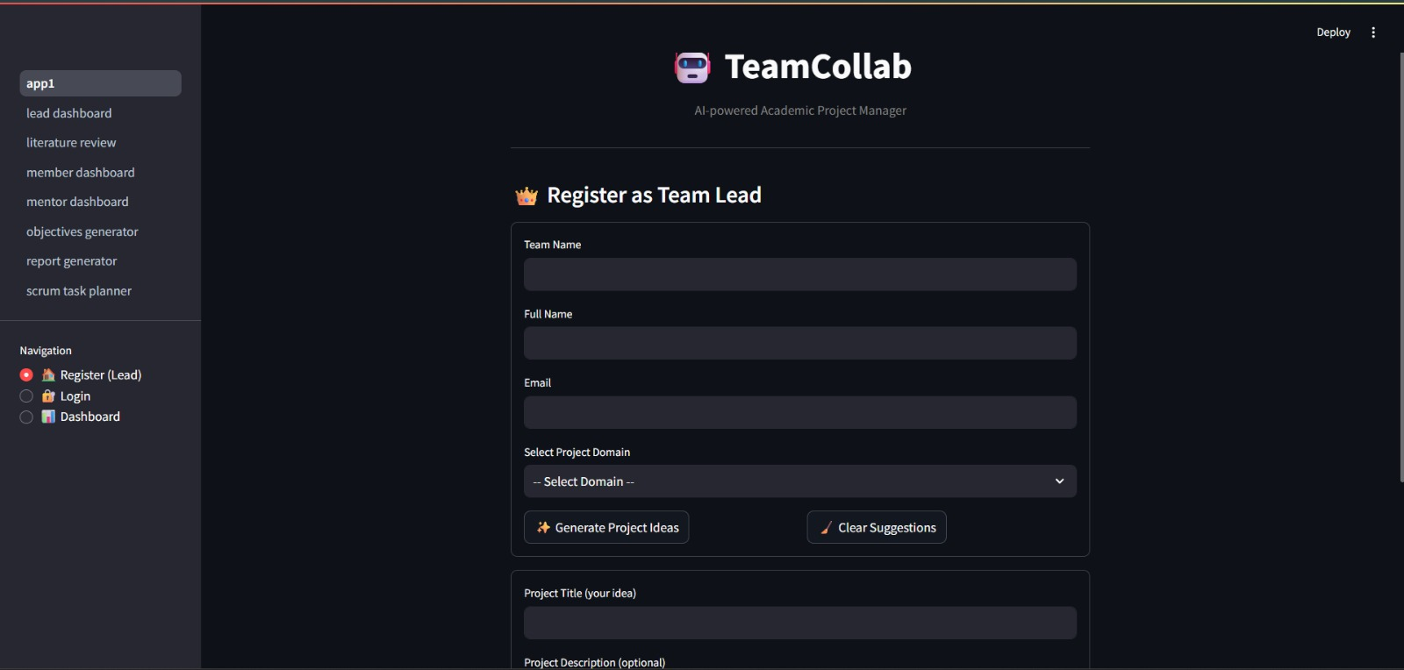
Fig 14: Registration Page

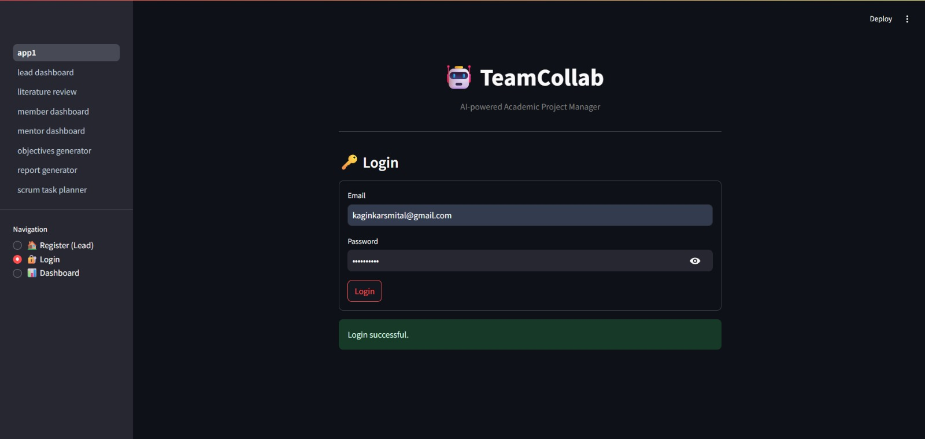
Fig 15: Login Page

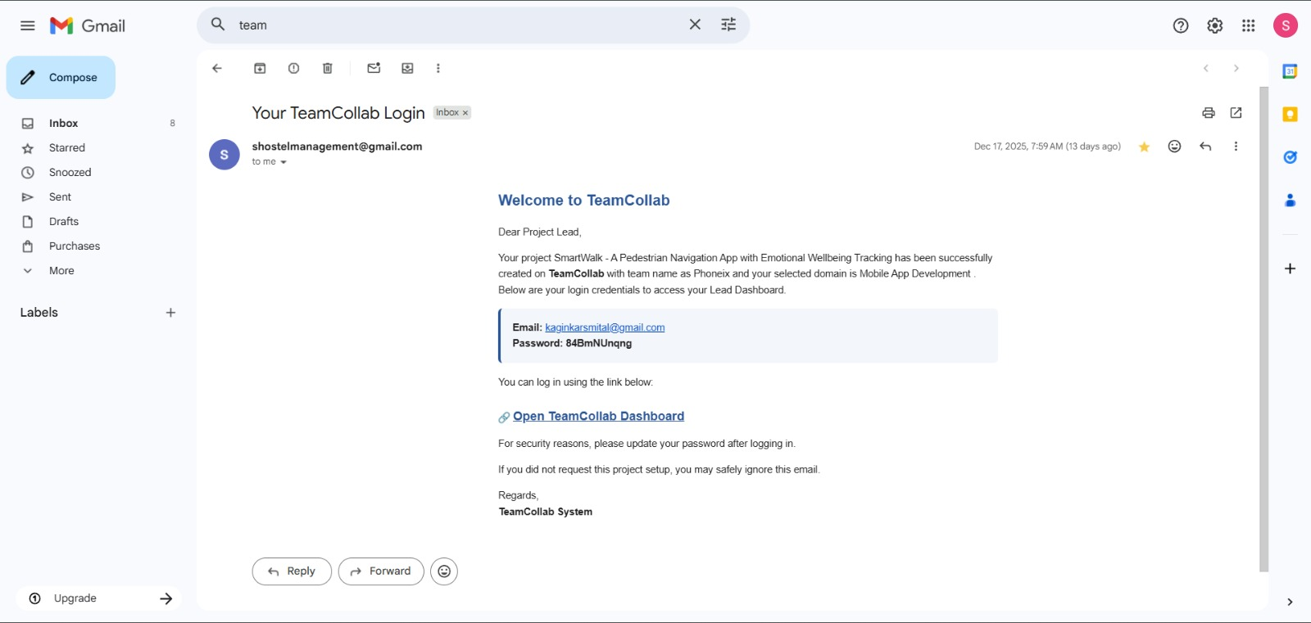
Fig 16: Lead Credentials Page

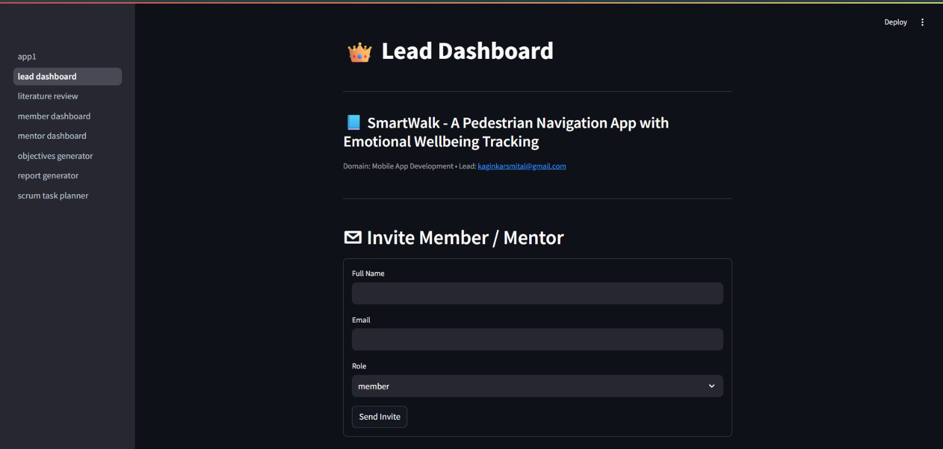
Fig 17: Lead Dashboard Page

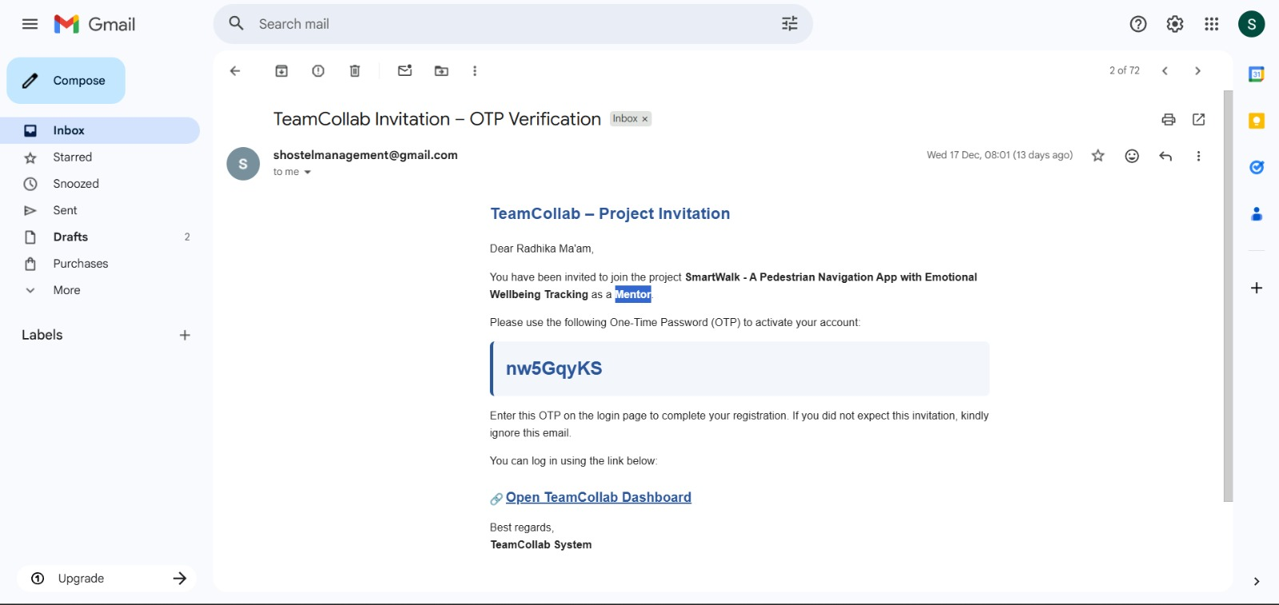
Fig 18: Mentor credentials Page

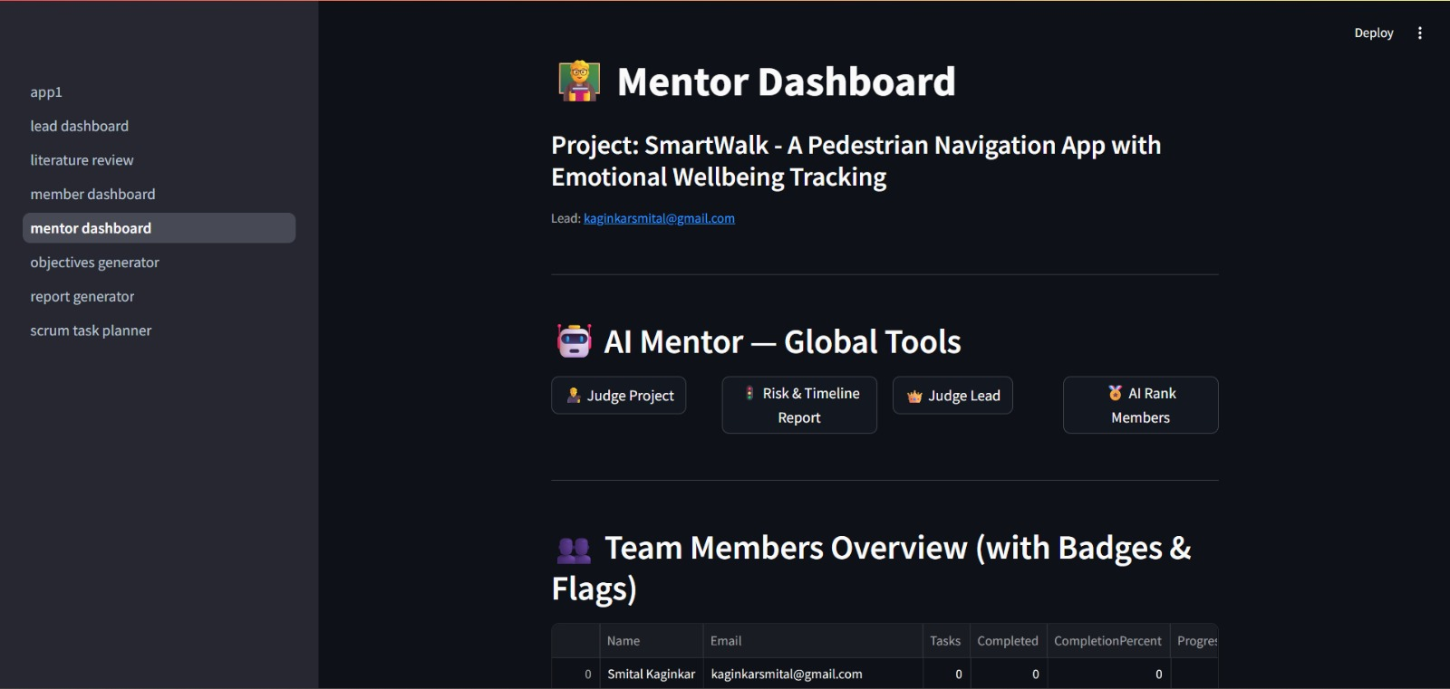
Fig 19: Mentor Dashboard Page

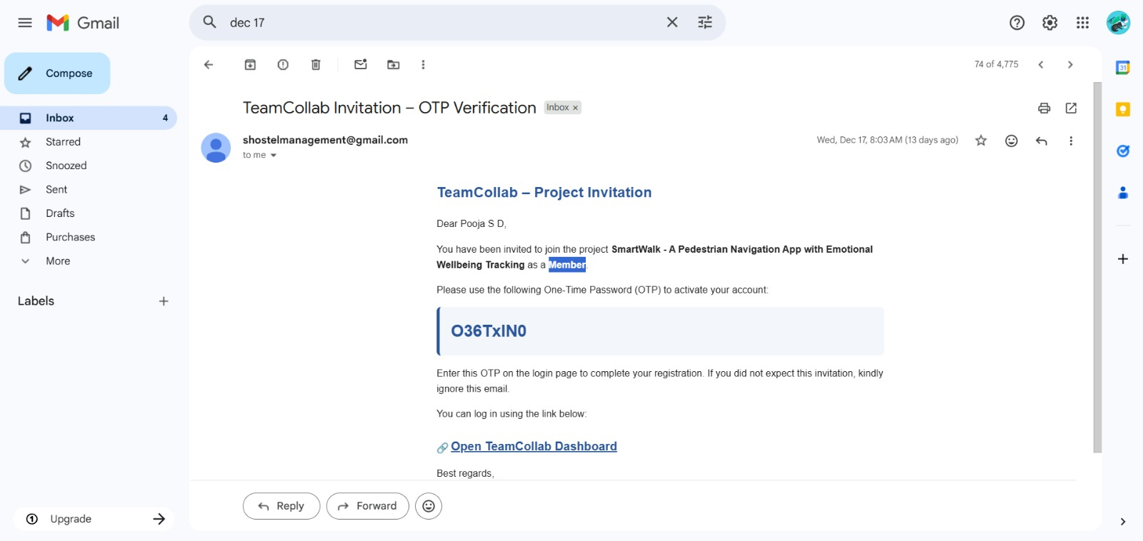
Fig 20: Member Credentials Page

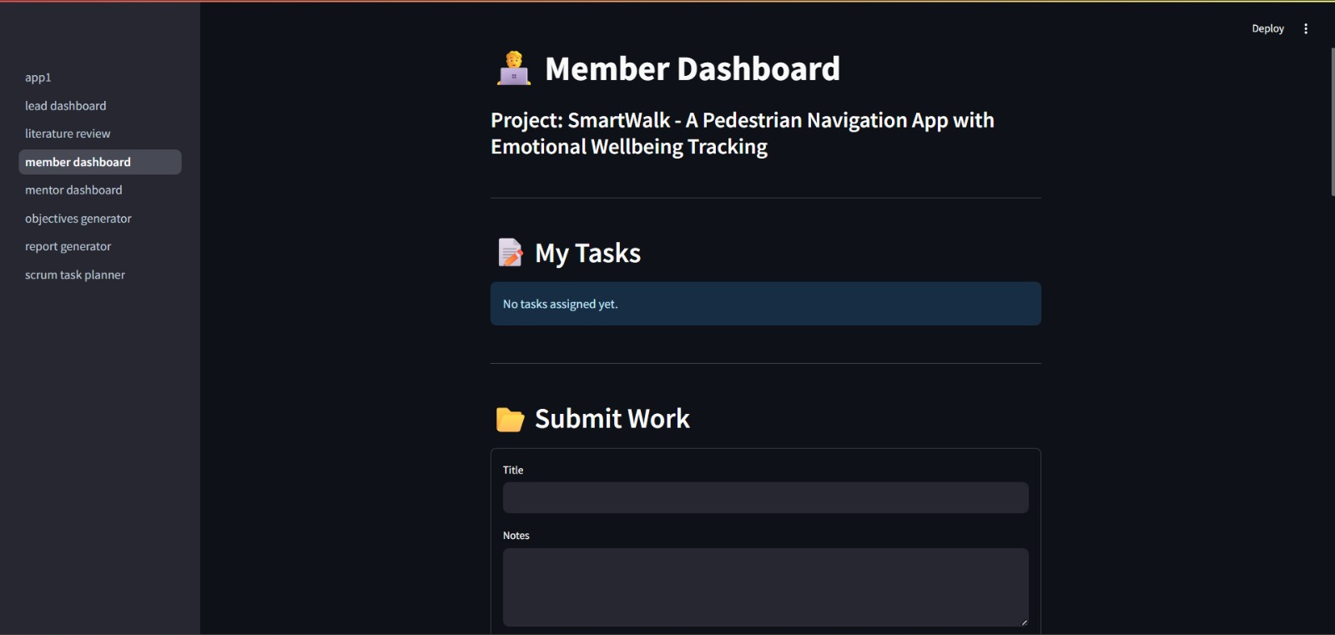
Fig 21: Member Dashboard Page

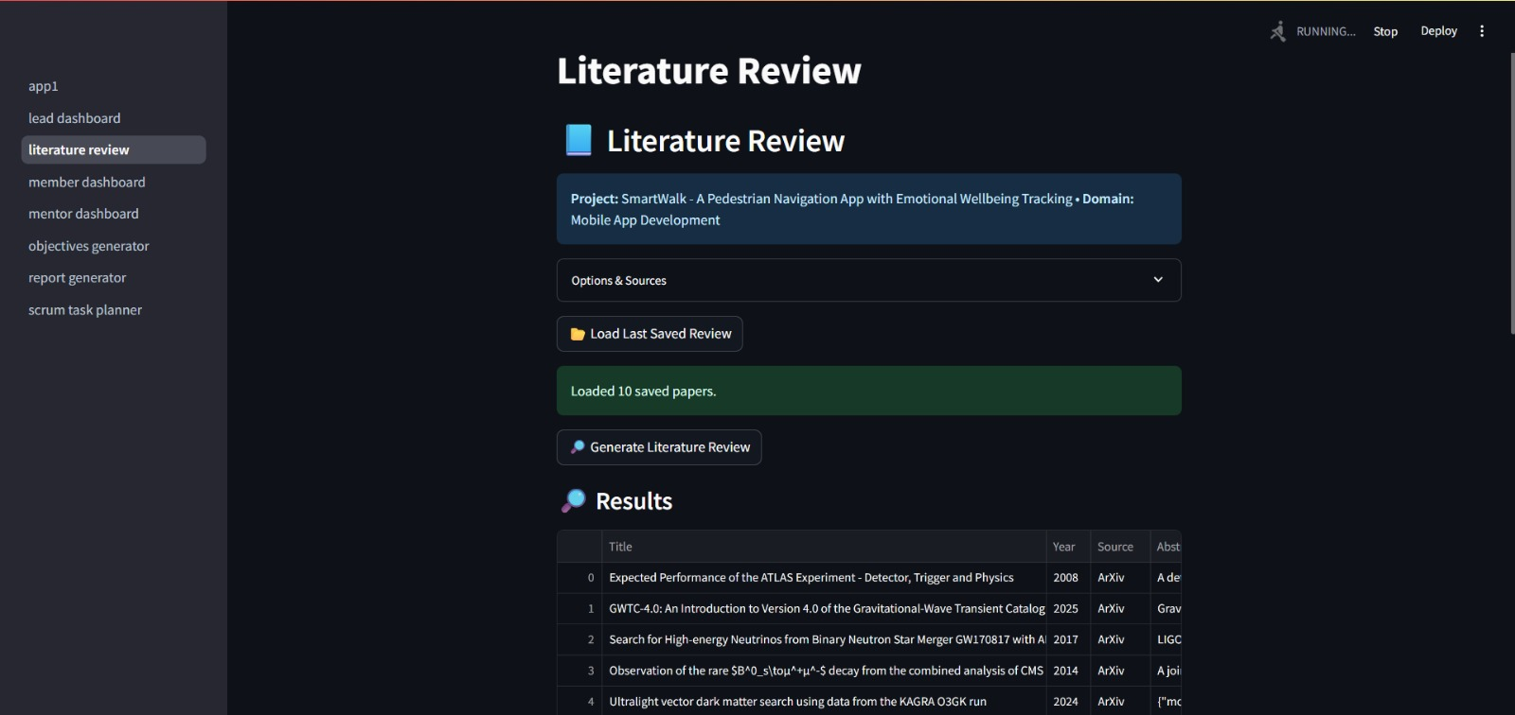
Fig 22: Literate Review Agent Page

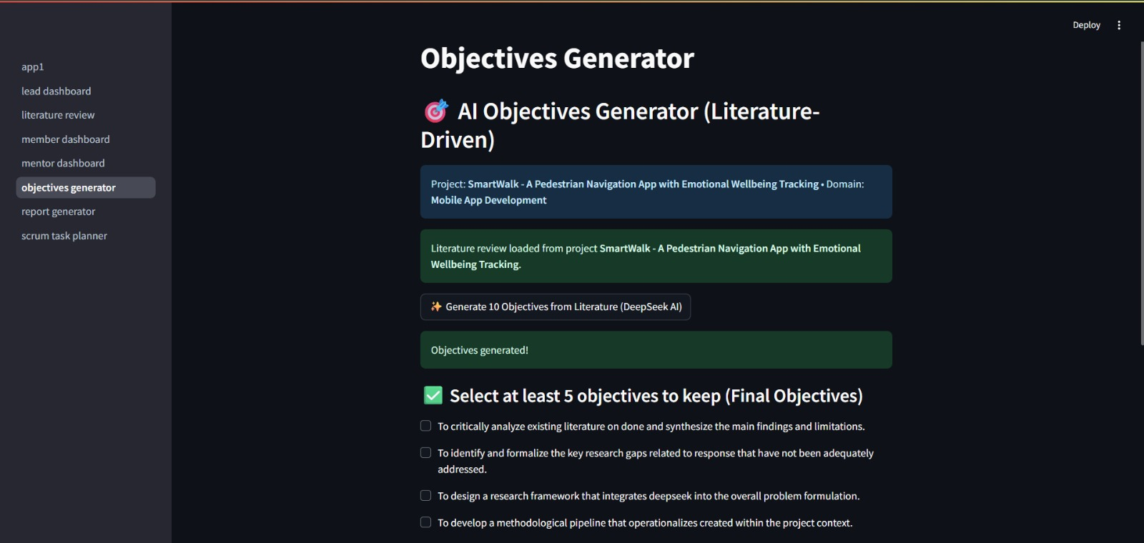
Fig 23: Objectives Generator Page

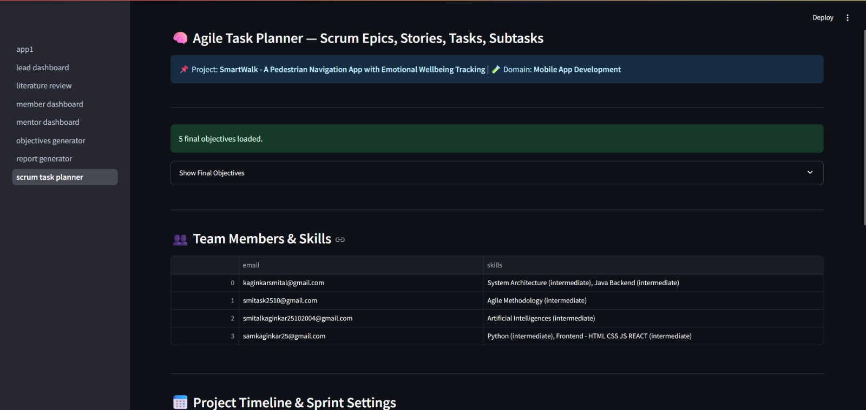
Fig 24: Agile Scrum Planner Page

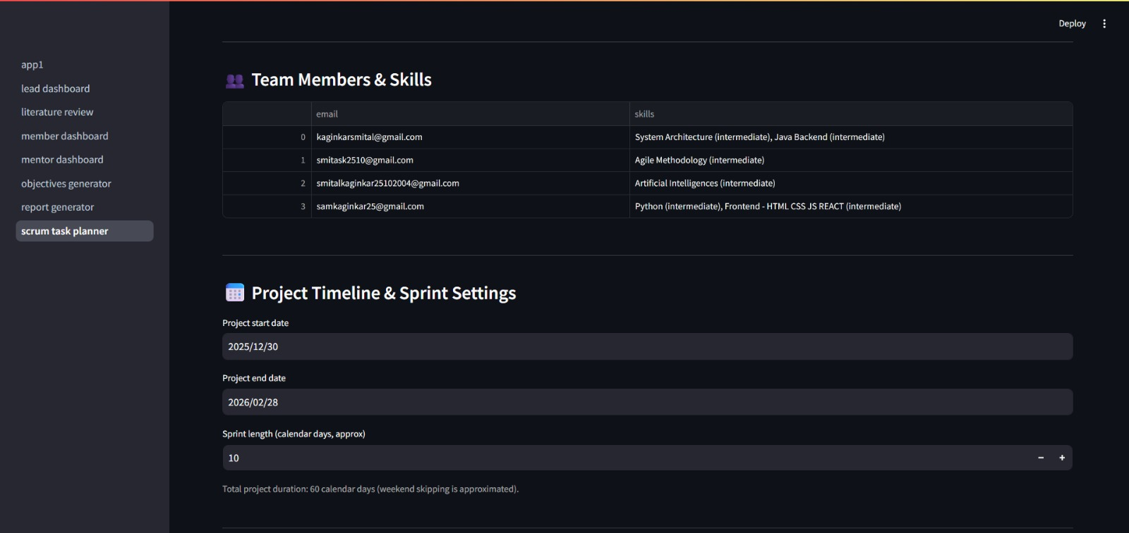
Fig 25: Project Timelines Page

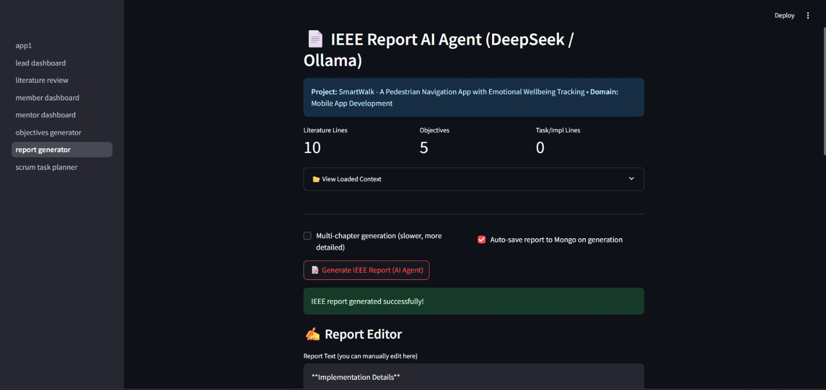
Fig 26: IEEE Report Generator Page

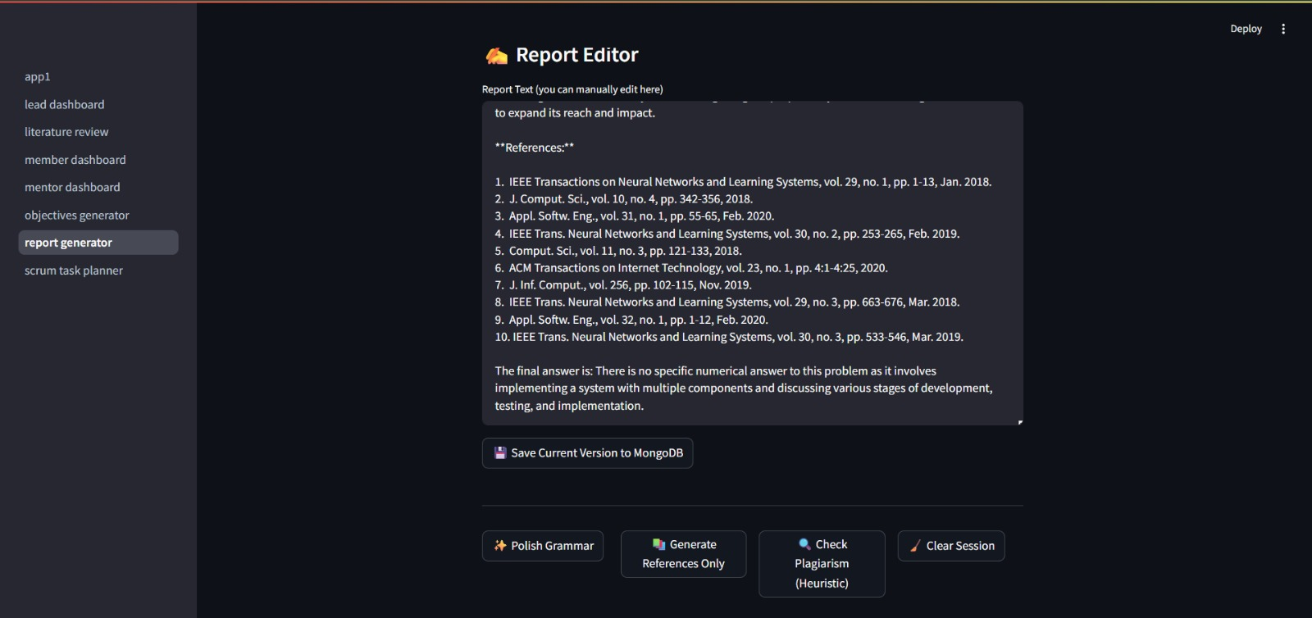
Fig 27: Report Editor Page

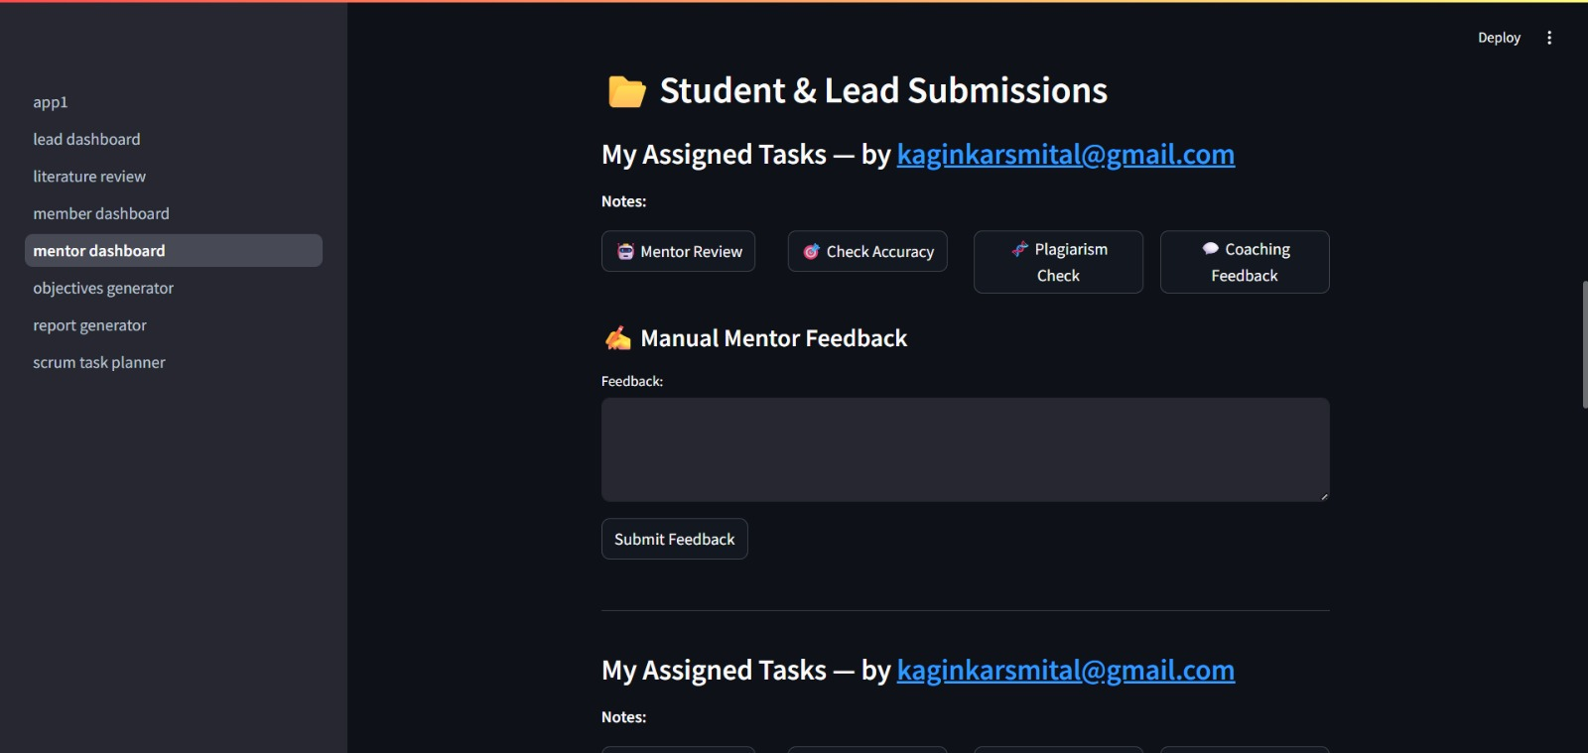
Fig 28: Mentor Feedback Page

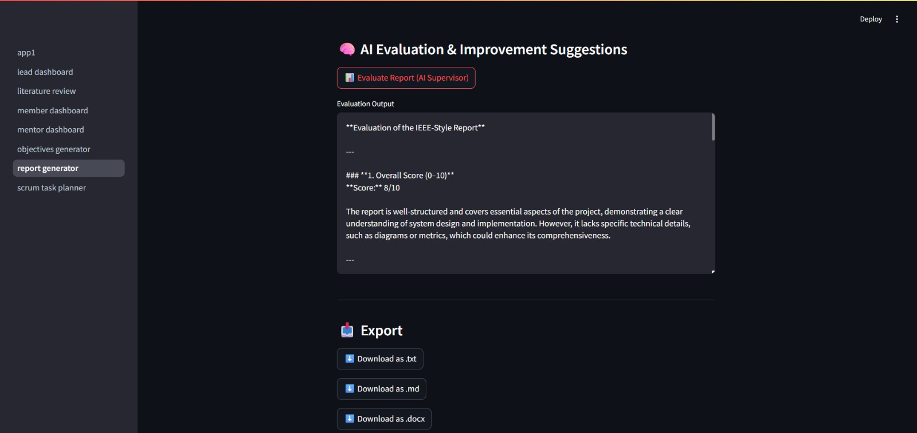
Fig 29: AI Evaluation and Feedback Page

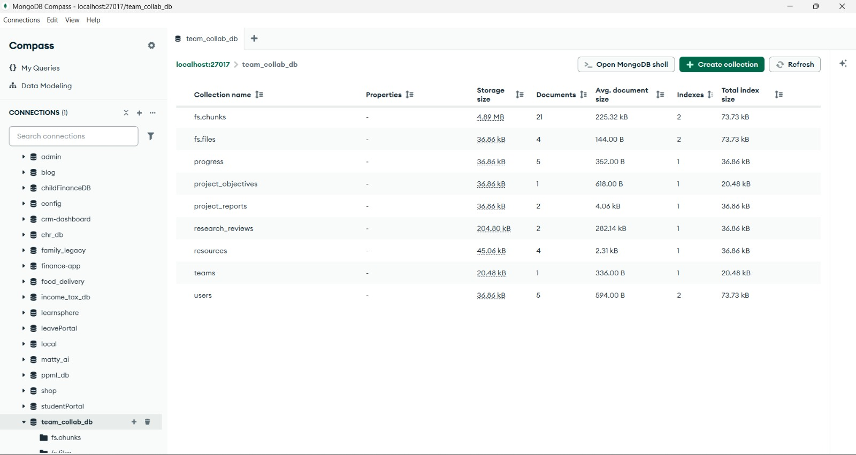
Fig 30: MongoDB Collections

CHAPTER 9
CONCLUSION
Academic project management is a critical aspect of higher education, as it directly influences the quality of learning outcomes, teamwork efficiency, and successful project completion. Traditional approaches to managing academic projects often rely on manual coordination, fragmented tools, and limited mentor involvement, which lead to inefficiencies, uneven task distribution, delayed progress, and compromised academic quality. Addressing these challenges requires a structured and intelligent system that aligns academic requirements with modern project management practices.
The proposed system, TeamCollab, effectively addresses these issues by integrating AI-driven automation with structured academic workflows. By leveraging intelligent AI agents, the system supports students throughout the entire project lifecycle, from project ideation and literature review to task planning, progress tracking, and report generation. The use of role-based dashboards for Project Leads, Mentors, and Members ensures clarity in responsibilities, improved coordination, and enhanced visibility into project progress. Automation of repetitive tasks such as literature summarization, objective formulation, and documentation significantly reduces manual effort and allows students to focus on innovation and implementation.
TeamCollab also improves collaboration and accountability by providing real-time progress monitoring, and structured communication channels. The integration of agile Scrum-based task planning ensures balanced workload distribution and timely completion of deliverables. Additionally, mentor dashboards equipped with AI-assisted evaluation tools enhance academic supervision and feedback, contributing to improved project quality and adherence to academic standards. The use of local LLM inference through Ollama further ensures data privacy, reliability, and offline usability, making the system suitable for academic environments with limited internet connectivity.
Overall, TeamCollab demonstrates that the integration of Artificial Intelligence into academic project management can significantly enhance efficiency, collaboration, and learning outcomes. The system not only simplifies project execution but also bridges the gap between academic project requirements and professional project management practices. By providing a scalable, secure, and user-friendly platform, TeamCollab serves as an effective solution for modern academic project planning and management, ultimately preparing students to handle complex, real-world projects with confidence and competence.

REFERENCES
[1] Wrike, “AI-powered project management software,” Wrike Inc., 2025. [Online]. Available: https://www.wrike.com
[2] SciSummary, “AI-based scientific article summarization tool,” 2023. [Online]. Available: https://scisummary.com
[3] A. Smith, J. Liu, and R. Kumar, “AI-based task modeling using large multimodal models and digital twins,” IEEE Access, vol. 13, pp. 44512–44526, 2025.
[4] Iris.ai, “AI-powered research discovery and literature review platform,” 2025. [Online]. Available: https://iris.ai
[5] M. Zhang and L. Wang, “AI-optimized task allocation for software project management,” Journal of Systems and Software, vol. 198, Art. no. 111235, 2024.

